History Page

**Introduction**

The history page feature in the website focuses on displaying a table with every transaction the member initiates. The history page is different to the transactions table in the main page as the transactions table only shows the transactions associated to the selected portfolio whereas, the history page shows every transaction the member initiated.

Scenario: Member should be able to view an updated history of every transaction made by them

User Story 1:

**User Story:** As a member, I want to view all of my transaction’s history within my account so that I can track progress throughout my account.

**Details:** All members will have access to the history page, there will be a table representing all transaction made within the account which the member can view at any time and keep updated.

**Test:** In the history page, check to see if there is a history table and that it shows every transaction made by member. Also check to see if data in table corresponds with the data entered.

UML Use Case Scenario:

|  |  |
| --- | --- |
| Use case name | View History Table |
| Participating actors | Member |
| Flow of events:  Normal flow | 1. Member is directed to main page after login 2. Member navigates to history page 3. Member can view history table |
| Flow of events:  Alternative flow | No Transactions:   1. Member is directed to main page after login 2. Member navigates to history page 3. Member cannot view history table as there are no transactions made |
| Pre-condition | Member hasn’t viewed history table |
| Post-condition | Member has viewed history table  Member hasn’t viewed history table |

UML Use Case Diagram:

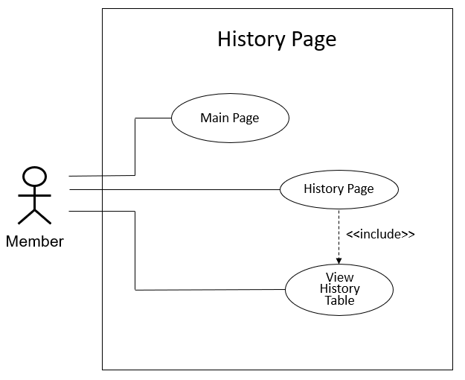

UML Sequence Diagram:

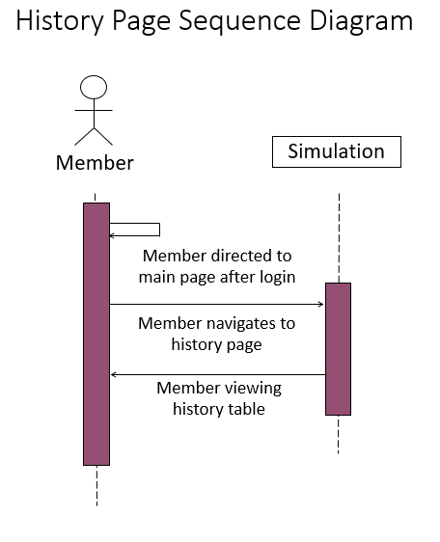

User Story 2:

**User Story:** As a member, I want to view an updated table of all my transaction’s history within my account so that I can track progress throughout my account.

**Details:** All members will have access to the history page, there will be a table representing all transactions made within the account. Once a currency is bought or an amount of a currency is sold, then the history table will be updated with the transaction type (Bought/Sold), amount bought or sold and the time the member bought or sold the currency. Every member will be able to view the history table at any time and keep updated.

**Test:** In the history page, check to see if history table in the history page is updated every time a transaction is made. Also check to see if updated data corresponds with the data entered.

UML Use Case Scenario:

|  |  |
| --- | --- |
| Use case name | Update History Table |
| Participating actors | API |
| Flow of events:  Normal flow | 1. Member is directed to main page after login 2. Member navigates to portfolio page to create a portfolio with a starting balance before buy or sell 3. Member selects a portfolio 4. Member navigates back to main page 5. Member initiates buy or sell 6. History table is updated with the currency bought/sold, the amount bought/sold, the transaction type (if currency is bought or sold) and the time the currency is bought at |
| Flow of events:  Alternative flow | Incorrect Data Format:   1. Member is directed to main page after login 2. Member navigates to portfolio page to create a portfolio with a starting balance before buy or sell 3. Member selects a portfolio 4. Member navigates back to main page 5. Member initiates buy or sell 6. History table is not updated with the currency bought/sold, the amount bought/sold, the transaction type (if currency is bought or sold) and the time the currency is bought at due to incorrect data format entered   Insufficient Funds:   1. Member is directed to main page after login 2. Member navigates to portfolio page to create a portfolio with a starting balance before buy or sell 3. Member selects a portfolio 4. Member navigates back to main page 5. Member initiates buy or sell 6. History table is not updated with the currency bought/sold, the amount bought/sold, the transaction type (if currency is bought or sold) and the time the currency is bought at due to insufficient funds |
| Pre-condition | History table not updated |
| Post-condition | History table updated  History table not updated |

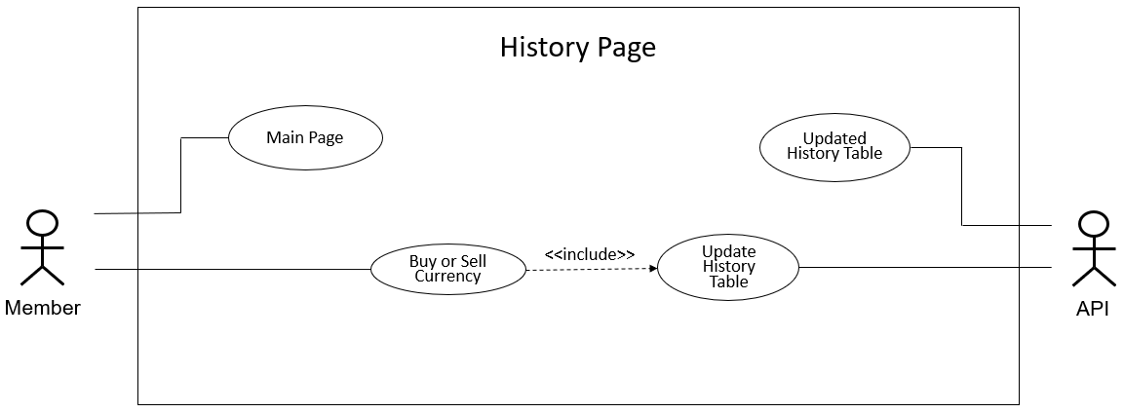UML Use Case Diagram:

UML Sequence Diagram:

